**Ingeniería del tráfico**

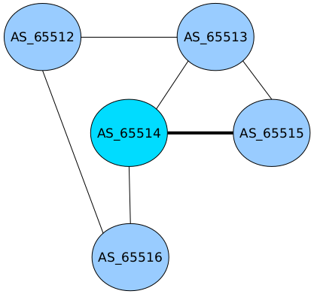

**Enunciado**

* Crea topología de red y utiliza como protocolo intradominio OSPFv4 y OSPFv6.
* Emplea ingeniería del tráfico para establecer el enlace marcado como principal y los otros dos dejarlos como enlaces de backup.

**Solución**

// ******************************** TOPOLOGÍA DE LA RED ****************************************

mkdir uml{1..5}

kwrite net.conf

// net.conf

defsw sw23 uml1.0 uml2.2

defsw sw34 uml2.1 uml3.0

defsw sw35 uml2.0 uml4.0

defsw sw34 uml3.1 uml4.1

defsw sw46 uml3.2 uml5.0

defsw sw26 uml1.1 uml5.1

sudo ifovsdel

sudo ifovsparse net.conf

lanza {1..4}

// ******************************** CONFIGURACIÓN ***********************************************

* Ejecutar en todas las máquinas:
  + sed -i -e 's/bgpd=no/bgpd=yes/' /etc/quagga/daemons
  + service quagga restart “o” systemctl restart quagga

1º) UML1

vtysh

write

configure terminal

ip forwarding

ipv6 forwarding

interface eth0

ip address 10.0.12.1/24

interface eth1

ip address 10.0.15.1/24

do write

router bgp 65512

neighbor 10.0.12.2 remote-as 65513

neighbor 10.0.15.5 remote-as 65516

network <<RedDeUsuarioFicticia>>

do write

2º) UML2

vtysh

write

configure terminal

ip forwarding

ipv6 forwarding

interface eth0

ip address 10.0.24.2/24

interface eth1

ip address 10.0.23.2/24

interface eth2

ip address 10.0.12.2/24

do write

router bgp 65513

neighbor 10.0.12.1 remote-as 65512

neighbor 10.0.23.3 remote-as 65514

neighbor 10.0.24.4 remote-as 65515

network <<RedDeUsuarioFicticia>>

do write

3º) UML3

vtysh

write

configure terminal

ip forwarding

ipv6 forwarding

interface eth0

ip address 10.0.23.3/24

interface eth1

ip address 10.0.34.3/24

interface eth2

ip address 10.0.35.3/24

do write

router bgp 65514

neighbor 10.0.23.2 remote-as 65513

neighbor 10.0.34.4 remote-as 65515

neighbor 10.0.35.5 remote-as 65516

network <<RedDeUsuarioFicticia>>

do write

end

configure terminal

route-map ruta-preferente-rm permit 10

match as-path preferente

set local-preference 200

do write

exit

route-map ruta-secundaria-rm permit 10

set as-path prepend 65514 65514 65514 65514 65514 65514 65514 65514

do write

exit

router bgp 65514

neighbor 10.0.34.4 route-map ruta-preferente-rm in

neighbor 10.0.35.5 route-map ruta-secundaria-rm out

neighbor 10.0.23.2 route-map ruta-secundaria-rm out

do write

4º) UML4

vtysh

write

configure terminal

ip forwarding

ipv6 forwarding

interface eth0

ip address 10.0.24.4/24

interface eth1

ip address 10.0.34.4/24

do write

router bgp 65515

neighbor 10.0.24.2 remote-as 65513

neighbor 10.0.34.3 remote-as 65514

network <<RedDeUsuarioFicticia>>

do write

5º) UML5

vtysh

write

configure terminal

ip forwarding

ipv6 forwarding

interface eth0

ip address 10.0.35.5/24

interface eth1

ip address 10.0.15.5/24

do write

router bgp 65516

neighbor 10.0.35.3 remote-as 65514

neighbor 10.0.15.1 remote-as 65512

network <<RedDeUsuarioFicticia>>

do write

// ******************************** COMPROBACIÓN ************************************************

do clear bgp ip *

do show ip bgp

do show ip route

do show ip route bgp